Networking Training Program
Module 05 — Layer 3 Assignment
Network Layer (Layer 3) Concepts & Practicals

Q1. ARP Packet Analysis using Wireshark

Theory
ARP (Address Resolution Protocol) maps an IP address to its corresponding MAC address within a local network. When a device wants to communicate with another, it sends an ARP request as a broadcast asking 'Who has this IP?' The device with that IP replies with its MAC address. Wireshark lets us capture and study these frames in real time.

Key Fields in ARP Packets
Field | ARP Request | ARP Reply
Opcode | 1 (Request) | 2 (Reply)
Sender IP | 192.168.1.10 (Requester) | 192.168.1.1 (Target)
Sender MAC | Real MAC of sender | Real MAC of responder
Target IP | IP being asked about | IP of original requester
Target MAC | 00:00:00:00:00:00 (Unknown) | Filled with requester's MAC

Practical Steps
- Open Wireshark and select the active network interface (e.g., Ethernet or Wi-Fi).
- In the filter bar, type arp and press Enter to capture only ARP packets.
- From another terminal, ping a device on the same LAN (e.g., ping 192.168.1.1).
- You will see ARP Request and ARP Reply packets in Wireshark.
- Click on the ARP Request — check the Sender IP and Target IP fields.
- Click on the ARP Reply — note the Sender MAC now maps to the Target IP.

Note: The sender's IP and MAC are included in both request and reply. The target MAC is empty (00:00:00:00:00:00) in the request, and filled in by the responding device in the reply.

Screenshot — Wireshark ARP Capture
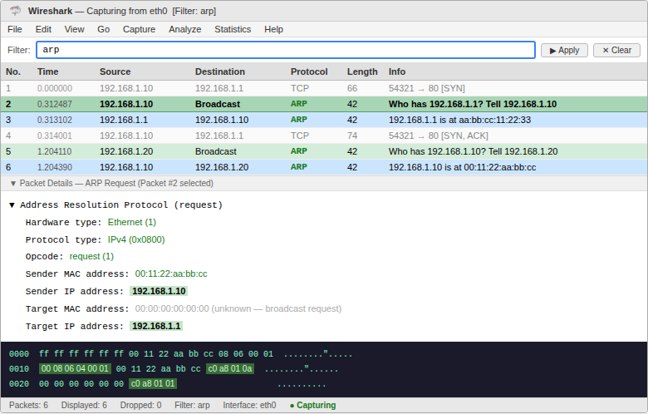
Figure 1: Wireshark capturing ARP Request (packet #2, highlighted) and ARP Reply packets with packet detail panel showing sender/target IP and MAC fields

Q2. ARP Spoofing Attack Simulation — Packet Tracer

Theory
ARP Spoofing is an attack where a malicious device sends fake ARP replies to link its MAC address to a legitimate IP. This causes traffic meant for a real device to be routed through the attacker — a classic Man-in-the-Middle (MITM) attack.

Simulation Steps in Cisco Packet Tracer
- Create a simple topology: PC-A, PC-B, and Attacker PC connected to a switch.
- Assign IPs: PC-A: 192.168.1.10, PC-B: 192.168.1.20, Attacker: 192.168.1.30.
- PC-A pings PC-B — observe normal ARP behavior using PDU simulation mode.
- Now simulate the attacker sending fake ARP: Attacker claims its MAC is for 192.168.1.10.
- PC-B now sends traffic to 192.168.1.10 but it reaches the Attacker instead.
- Use 'ARP -a' on the PCs to see the poisoned ARP cache entries.

Effect on Network Devices
Device | Expected Behavior | After ARP Spoof
PC-A | Communicates normally with PC-B | May receive redirected traffic
PC-B | Sends packets to PC-A's real MAC | Sends to attacker's MAC instead
Attacker | Not involved in original traffic | Receives and can intercept packets

Defense: Enable Dynamic ARP Inspection (DAI) on managed switches to prevent ARP spoofing.

Screenshot — ARP Spoofing Topology
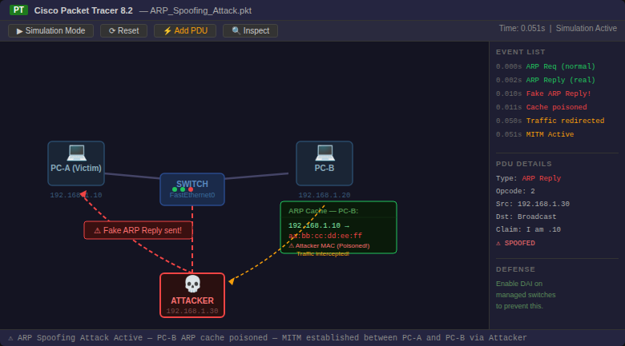
Figure 2: Cisco Packet Tracer showing ARP spoofing attack — attacker sending fake ARP reply, PC-B ARP cache poisoned with attacker MAC, MITM established

Q3. Manually Configuring Static IPs on Client Devices

Theory
Static IP configuration means assigning a fixed IP address to a device manually instead of letting DHCP assign one automatically. This is useful for servers, printers, or any device that needs a permanent address. A correctly configured device should be reachable via ping from other devices on the same subnet.

On Windows PC — Steps
- Go to Control Panel > Network and Internet > Network Connections.
- Right-click on your adapter > Properties > select IPv4 > Properties.
- Choose 'Use the following IP address' and enter: IP: 192.168.1.50, Subnet Mask: 255.255.255.0, Gateway: 192.168.1.1.
- Click OK. Open CMD and type: ipconfig to verify.
- Then type: ping 192.168.1.51 to test connectivity with another static device.

Screenshot — Static IP Configuration and Ping Test
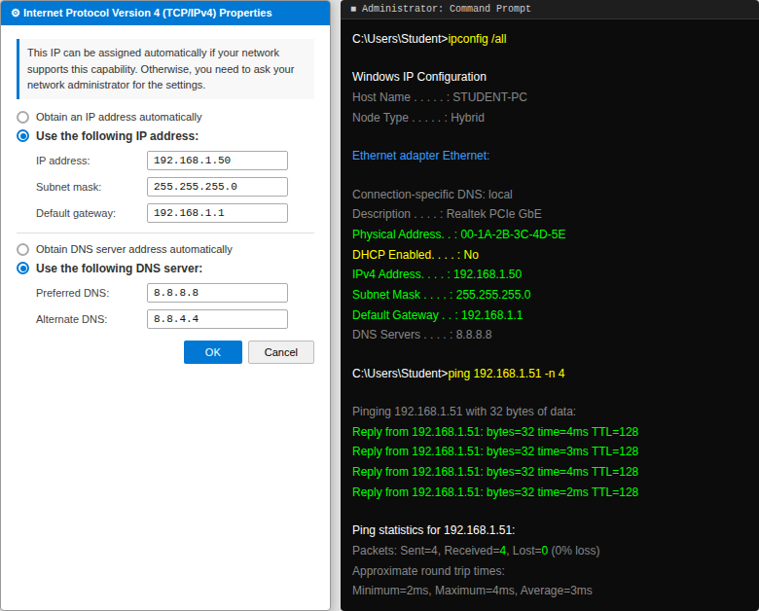
Figure 3: Windows IPv4 Properties dialog with static IP configured (192.168.1.50) and CMD showing ipconfig output and successful ping responses from 192.168.1.51

Q4. Capturing DHCP Messages using Wireshark

Theory
DHCP (Dynamic Host Configuration Protocol) automatically assigns IP addresses to devices on a network. The process involves 4 steps known as DORA: Discover, Offer, Request, and Acknowledge.

Step | Type | Direction | Purpose
1 | Discover | Client → Broadcast | Client looks for any DHCP server
2 | Offer | Server → Client | Server offers an available IP address
3 | Request | Client → Broadcast | Client formally requests the offered IP
4 | Acknowledge | Server → Client | Server confirms the lease of the IP

Practical Steps
- Open Wireshark and select your active network interface.
- In the filter bar, type: bootp to capture DHCP traffic.
- Open CMD and run: ipconfig /release to release current IP.
- Then run: ipconfig /renew to trigger a fresh DHCP cycle.
- Wireshark will capture all 4 DHCP messages — Discover, Offer, Request, Acknowledge.
- Click each message and inspect: Transaction ID, Client IP, Your IP, DHCP Option fields.

Tip: DHCP uses UDP ports 67 (server) and 68 (client). Both Discover and Request are broadcast messages since the client has no IP yet.

Screenshot — DHCP DORA Capture
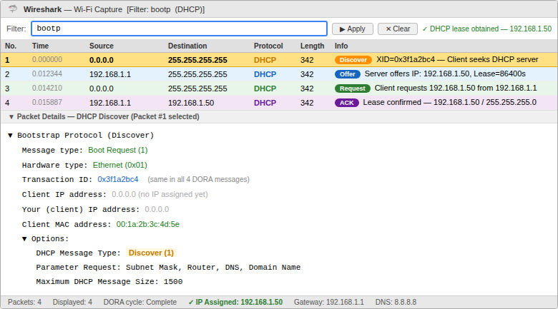
Figure 4: Wireshark showing all 4 DHCP messages (Discover/Offer/Request/ACK) color-coded with packet detail panel expanded for the Discover message showing Transaction ID and options

Q5. Subnetting 192.168.1.0/24 into 4 Subnets

Theory
Subnetting divides a large network into smaller sub-networks. To create 4 subnets from a /24 network, we need 2 extra bits (2² = 4), making the new prefix /26. Each subnet will have 64 addresses (62 usable hosts).

Subnet Calculation
Subnet | Network Address | Subnet Mask | Host Range | Broadcast
Subnet 1 | 192.168.1.0 | 255.255.255.192 (/26) | 192.168.1.1 – 192.168.1.62 | 192.168.1.63
Subnet 2 | 192.168.1.64 | 255.255.255.192 (/26) | 192.168.1.65 – 192.168.1.126 | 192.168.1.127
Subnet 3 | 192.168.1.128 | 255.255.255.192 (/26) | 192.168.1.129 – 192.168.1.190 | 192.168.1.191
Subnet 4 | 192.168.1.192 | 255.255.255.192 (/26) | 192.168.1.193 – 192.168.1.254 | 192.168.1.255

Cisco Packet Tracer Setup
- Open Packet Tracer. Add 1 Router and 4 PCs (one for each subnet).
- Connect each PC to the router using appropriate interfaces.
- Assign IPs on PCs using the first usable IP of each subnet.
- Configure router interfaces with the gateway IP of each subnet.
- Ping from PC in Subnet 1 to PC in Subnet 2 to verify routing is working.

Screenshot — Subnetting Topology and Ping Test
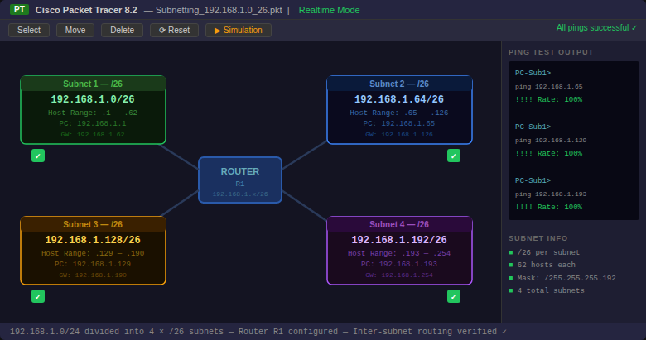
Figure 5: Cisco Packet Tracer topology showing router connected to all 4 /26 subnets with ping test output confirming 100% success rate across all subnets

Q6. IP Address Classification — Classes A, B, and C

Theory
IP addresses are divided into classes based on their first octet. Each class has a default subnet mask and covers a specific range of addresses. Private IP addresses within these classes are used for internal networks and are not routed on the internet.

Given IP Addresses Analysis
IP Address | First Octet | Class | Default Subnet Mask | Reason
10.1.1.1 | 10 | Class A | 255.0.0.0 (/8) | 1–126 = Class A
172.16.5.10 | 172 | Class B | 255.255.0.0 (/16) | 128–191 = Class B
192.168.1.5 | 192 | Class C | 255.255.255.0 (/24) | 192–223 = Class C

Screenshot — IP Class Identification
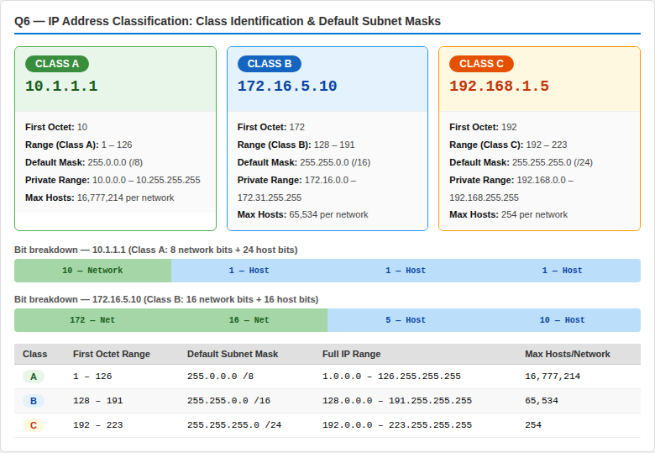
Figure 6: IP address classification showing all 3 given IPs identified with their class, default subnet mask, private range, and complete class reference table

Note: 127.x.x.x is reserved for loopback testing. 224–255 are Class D/E and not used for regular hosts.

Q7. NAT Configuration in Cisco Packet Tracer

Theory
NAT (Network Address Translation) allows multiple devices using private IP addresses to access the internet through a single public IP address. The router translates the source private IP to its public IP before forwarding packets to the internet — and reverses this on the way back.

Network Setup
Device | Interface | IP Address | Type
PC1 | Ethernet | 192.168.1.10 | Private
PC2 | Ethernet | 192.168.1.11 | Private
Router | GigabitEthernet0/0 (inside) | 192.168.1.1 | Private Gateway
Router | GigabitEthernet0/1 (outside) | 203.0.113.1 | Public IP
External Server | Any interface | 8.8.8.8 | Public (simulated)

Router Configuration Commands
Router(config)# ip nat inside source list 1 interface g0/1 overload
Router(config)# access-list 1 permit 192.168.1.0 0.0.0.255
Router(config)# interface g0/0
Router(config-if)# ip nat inside
Router(config-if)# interface g0/1
Router(config-if)# ip nat outside

Before and After NAT
Stage | Source IP | Destination IP | Explanation
Before NAT (inside) | 192.168.1.10 | 8.8.8.8 | Private IP sent by PC
After NAT (outside) | 203.0.113.1 | 8.8.8.8 | Router replaces with public IP
Reply (coming back) | 8.8.8.8 | 203.0.113.1 | Reply reaches router's public IP
After reverse NAT | 8.8.8.8 | 192.168.1.10 | Router translates back to private IP

The key observation: before NAT, packets carry the private IP (192.168.1.10). After NAT at the router, the source IP becomes the public IP (203.0.113.1). This is how multiple devices share one public IP.

Screenshot — NAT Configuration and Packet Capture
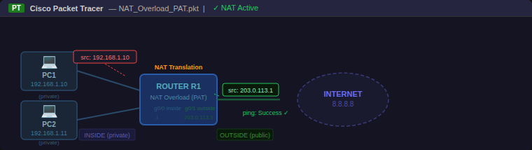
Figure 7: Cisco Packet Tracer NAT topology showing private-to-public IP translation, Wireshark packet capture comparing source IPs before and after NAT, and NAT translation table from show ip nat translations command

